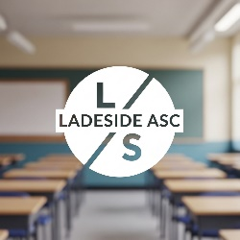

Ladeside Primary School ASC
Curriculum Rationale
Overview
2026/27

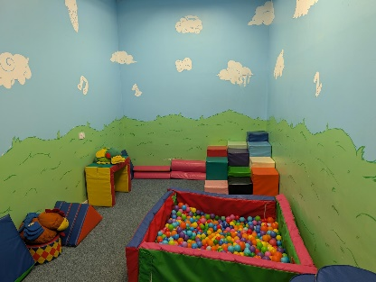
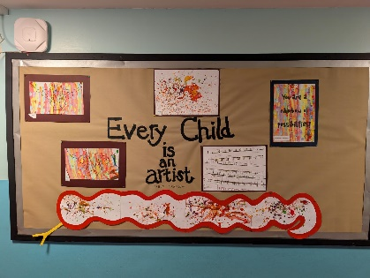
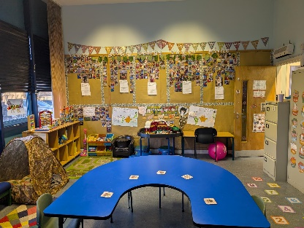

Ladeside Primary School Additional Support Centre (ASC)

Overarching Curriculum Rationale
This document outlines the overarching curriculum rationale for our seven classes within our Additional Support Centre (ASC) provision at Ladeside Primary School.
It serves as our collective vision and shared commitment to
“to provide a safe, happy and nurturing environment which allows each child to reach their full potential with dignity and respect.”
While each of our seven classes has a unique and highly specific curriculum tailored to its learners, this rationale describes the unified philosophy and core principles that bind our entire provision together.

Please also see Appendix 1 (A Day in the Life: Practical Applications for ASC Learners at Ladeside) towards the end of this Rationale which highlights practical strategies and visible practices you might observe in our ASC. These examples show how we cater to diverse learning styles and integrate our guiding frameworks in a day-to-day context.

Our Overarching Philosophy: A Relational and Well-being First Approach
Our fundamental belief is that relationships are the bedrock of all learning. We operate with a shared philosophy that a child who feels safe, secure, and understood is a child who is ready to learn. Therefore, the curriculum across our entire provision is built on a foundation of health, well-being, and nurturing relationships. Traditional academic progress is a secondary, though important, outcome of this secure and emotionally regulated state. We recognise that the path to learning may look different for each pupil, but it will always begin with a foundation of trust.

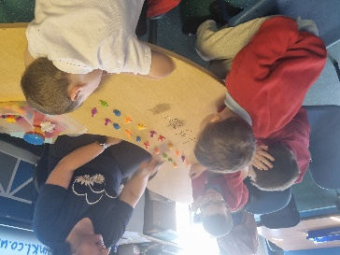
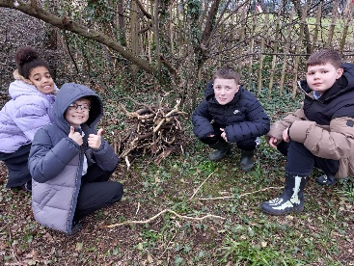

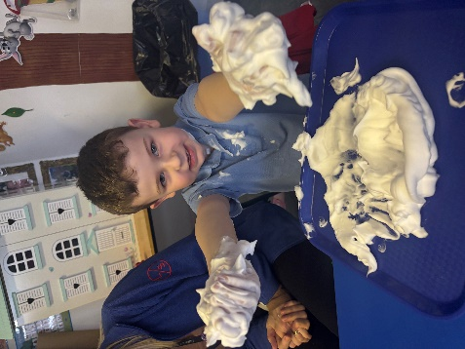

Understanding ASC Learner Styles: Embracing Diversity in Cognition
Our ASC learners often present with a range of social, cognitive and sensory processing differences that necessitate flexible and highly differentiated pedagogical approaches. Recognizing these diverse styles is fundamental to effective curriculum design and delivery:

- Visual Learners:
Many of our ASC learners process information more effectively through visual means. This necessitates the extensive use of visual schedules, social stories, visual timetables, now-and-next boards, PECS (Picture Exchange Communication System), visual cues, mind maps, and concept maps.
- Concrete & Literal Thinkers:
Abstract concepts can be challenging. Learning should be grounded in concrete experiences, real-world examples, and hands-on activities. Literal interpretation of language requires clear, unambiguous communication.
- Systematisers & Pattern Seekers:
Our ASC learners can often excel at identifying patterns, rules, and systems. Leveraging this strength through structured tasks, clear routines, logical sequencing, and opportunities for detailed exploration can be highly effective.
- Focused Interests:
Many of our ASC learners have intense, specific interests. These can be powerful motivators and leverage points for learning across the curriculum, fostering engagement and deeper understanding.
- Sensory Processing Differences:
ASC learners may be hyper- or hypo-sensitive to sensory input (e.g., sounds, lights, textures). The learning environment must be thoughtfully adapted to minimize sensory overload and provide sensory regulation opportunities (e.g., quiet spaces, sensory breaks, fiddle toys).
- Preference for Predictability & Routine:
Clear routines, predictable structures, and advance warning of changes reduce anxiety and promote a sense of safety and security, enabling better engagement in learning.
- Difficulty with Generalisation:
Skills learned in one context may not automatically transfer to another. Explicit teaching of generalisation strategies and opportunities to practice skills in varied settings are crucial.
- Processing Time:
ASC learners may require additional processing time for information, instructions, and social interactions. Providing adequate wait time is essential.
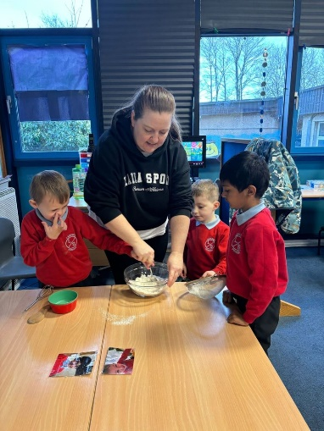
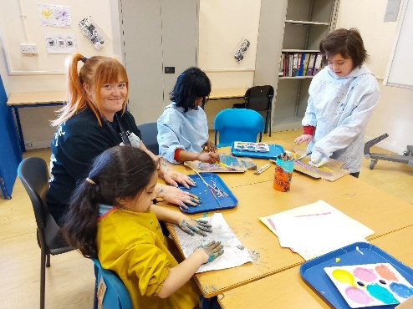
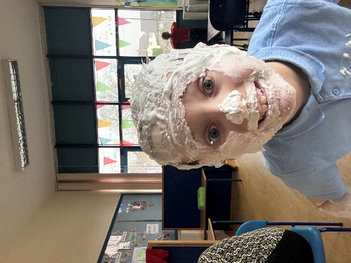

The Central Role of Play: 'Play is the Way'
We believe that play is the way for our ASC learners to explore, learn, and grow. Play is not just an activity; it is the primary method through which children make sense of the world, develop essential skills, and express themselves. For our ASC learners, a play-based curriculum can be particularly effective because it:
- Promotes Communication and Social Skills:
Structured and free play provides low-pressure, natural opportunities for children to initiate and respond to communication, share attention, and engage in social reciprocity.
- Fosters Creativity and Flexibility:
Play-based learning, especially in a guided setting, encourages imaginative thinking and helps learners develop cognitive flexibility and problem-solving skills in a safe environment.
- Supports Emotional Regulation:
Play can be a powerful tool for emotional expression and regulation. Sensory play, in particular, can help learners manage sensory input and find a calm, regulated state.
- Develops Motor Skills:
Both fine and gross motor skills are naturally developed through play, from manipulating small objects to engaging in physical activities.
Our curriculum integrates play at every stage, from Primary 1 to Primary 7, as it provides a multi-sensory and highly motivating context for learning.

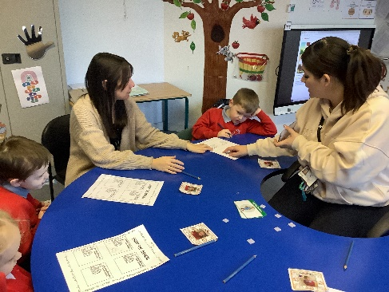

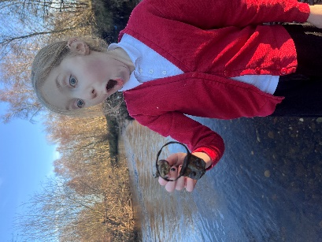
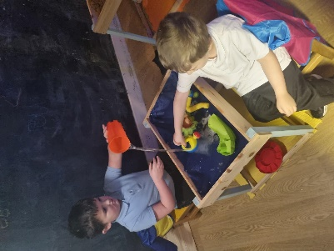

SCERTS Model (Social Communication, Emotional Regulation, Transactional Support)
The SCERTS model provides a comprehensive framework for understanding and supporting ASC learners by focusing on key developmental areas.
The principles of SCERTS are naturally integrated into our play-based approach:
- Social Communication (SC): We explicitly teach and facilitate functional social communication skills through play, including:
  - Joint Attention: Supporting shared focus on objects and activities during play.
  - Symbolic Play: Encouraging imaginative and flexible play skills.
  - Communication Functions: Developing a range of communicative intents (e.g., requesting, commenting, protesting) within a play context.
  - Social Reciprocity: Fostering back-and-forth interactions and understanding social cues during guided play.
  - Functional Communication Training: Using visuals, AAC (Augmentative and Alternative Communication), and explicit instruction to develop effective communication during playful interactions.

- Emotional Regulation (ER): We support ASC learners in understanding and managing their emotions through play-based activities:
  - Identifying Emotions: Teaching emotion vocabulary and recognition in self and others, often through role-playing and play scenarios.
  - Coping Strategies: Providing a toolkit of individualized regulation strategies (e.g., sensory breaks, safe spaces) which are often embedded within our ASC provision.
  - Self-Regulation Zones: Utilizing visual tools like "Talking Mats" to help children identify their emotional state and choose appropriate strategies, often connected to a play area or activity.
  - Understanding Triggers: Helping children and staff identify and mitigate sensory or social triggers for dysregulation in the play environment.

- Transactional Support (TS): This involves the deliberate creation of supportive environments and partnerships:
  - Interpersonal Support: Training staff to be responsive, predictable, and emotionally available, especially during play. Utilizing preferred interests to build rapport and guide play.
  - Learning Supports: Adapting tasks, providing visual supports, structuring activities, and breaking down complex information, all within the context of play.
  - Family Support: Partnering with families to ensure consistency of strategies between home and school, particularly around supporting play.
  - Professional Support: Collaborating with specialists (e.g. speech and language therapists, occupational therapists, educational psychologists) to provide integrated support during play sessions.
Guiding National Frameworks
Our ASC provision is fully aligned with Scotland's national educational guidance. We are not a separate entity, but an integrated part of the school community, with our work being a direct application of the following frameworks:
- Getting it Right for Every Child (GIRFEC): GIRFEC is at the heart of our practice. Our curriculum is entirely person-centred, with a relentless focus on the SHANARRI indicators. We prioritize our pupils being Safe, Nurtured, and Respected, as these are prerequisites for learning and development. Our inter-agency work and collaborative planning are rooted in this framework.
- Curriculum for Excellence (CfE): CfE provides the flexible framework for our learning and teaching. We strive to help all our pupils become Successful Learners, Confident Individuals, Responsible Citizens, and Effective Contributors. Our approach is unique in that these capacities are often developed through highly individualized and non-traditional methods, such as play, sensory experiences, and special interests, rather than formal, pre-planned tasks.
- How Good Is Our School? (HGIOS 4): Our provision uses the HGIOS quality indicators for self-evaluation and improvement. We focus particularly on indicators related to the quality of our learning environment, the effectiveness of our relationships, and the holistic well-being of our pupils. These indicators guide our continuous journey of self-reflection and professional development.

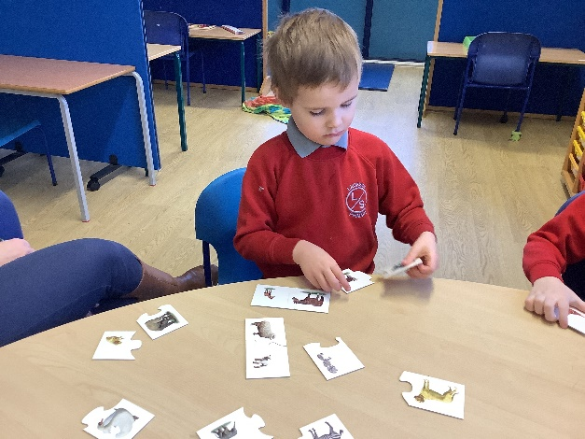
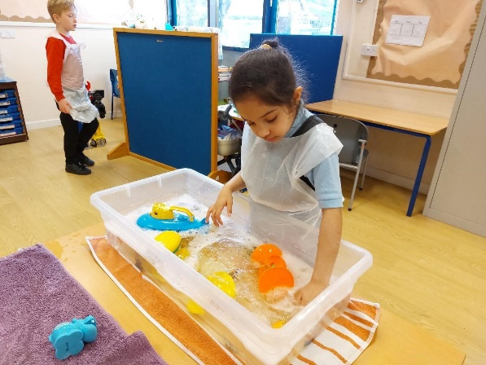

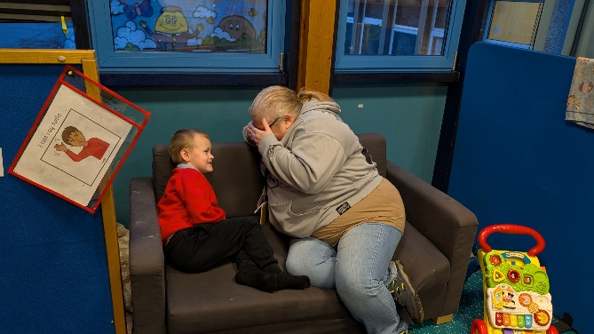

The Unique Curricula of Each Class
While our philosophy is shared, we explicitly recognise that a one-size-fits-all curriculum would not meet the complex needs of our pupils. Each of our seven classes has a unique composition of learners, and as such, each class has its own highly specific and tailored curriculum rationale.
- Diverse Profiles: Our classes are intentionally organized to meet the specific profiles of our learners. For example, one class may focus on a play-based, sensory-driven approach for non-verbal pupils, while another may operate on a relational, low-demand model for pupils with high anxiety.
- Individualised and Responsive: The content and pace of each curriculum are highly responsive to the pupils' needs. The specific documents for each class detail the approaches to literacy, numeracy, and health and well-being that are most effective for that particular cohort.

Parental Engagement
We believe that parents and carers are the foremost experts on their children. Our partnership with them is built on mutual respect and open communication. We share our observations and evidence of progress regularly, and we seek their input on what is working well at home and what interests their child. This collaboration ensures our approaches are consistent and effective.

A Culture of Continuous Review
To ensure our practice remains at the forefront of additional support needs education, the specific curriculum rationale for each class is a living document. It is reviewed and updated annually by the class teacher and principal teacher, in consultation with parents and other key professionals. This process allows us to adapt to the changing needs of the pupils, integrate new research, and refine our approach to guarantee the best possible outcomes.

Conclusion
This overarching curriculum rationale serves as a unified statement of our commitment to our pupils. By anchoring our practice in our core values and national frameworks, while allowing each of our classes the freedom to create a unique curriculum, we ensure a compassionate, effective, and deeply respectful educational experience. We believe that this collaborative and individualized approach is the most powerful way to support our pupils in achieving their full potential and flourishing in our school community.

Appendix 1 - A Day in the Life: Practical Applications for ASC Learners at Ladeside
This additional document provides a brief overview of the practical strategies and visible practices you might observe in our ASC classes, demonstrating how we implement our curriculum rationale for all ASC learners.
These examples show how we cater to diverse learning styles and integrate our guiding frameworks in a day-to-day context.

1. Visual and Structured Learning
- Visual Timetables and Now/Next Boards:
You will see a large, clear visual timetable in each classroom showing the sequence of the school day. Individual pupils may have a personal "Now/Next" board on their desk to help them transition between activities.
- Work Stations and Independent Work Trays:
Pupils may have their own designated work station with individual task trays. Each tray contains activities with a clear start and finish, promoting independence and reducing cognitive load. Tasks are often colour-coded or use symbols.
- Social Stories:
You might see social stories displayed on walls or being read individually with a pupil. These are short narratives with visuals that explain a social situation, skill, or concept in a structured, literal way to help prepare pupils for an event (e.g., a fire alarm practice or a school trip).

2. Play-Based and Sensory Learning
- Structured Play Areas:
Play areas are often carefully arranged with clear boundaries and a reduced number of toys to minimize sensory overload. They are rotated regularly to maintain interest.

- Sensory Play and Fiddle Boxes: You may observe dedicated "Sensory Play" areas with a variety of textures, materials (e.g., kinetic sand, water beads), and lights. Fiddle boxes containing small, calming items (e.g., fidget spinners, stress balls) are readily available on desks or in a central location for pupils to access as needed.

- Movement and Sensory Breaks:
Pupils may be seen using a visual timer for short, scheduled "sensory breaks," which could involve a brief walk, using a wobble cushion, or a quick session on a trampoline. This is a practical application of the GIRFEC principle of being Active and the SCERTS focus on Emotional Regulation.

3. Communication and Social Interaction
- Augmentative and Alternative Communication (AAC):
In some instances, pupils may use communication boards or devices to express themselves. Staff are trained to respond to these methods as readily as they would to verbal communication.
- Peer Support and Buddy Systems:
You will see pupils working in small groups or pairs, often with a trained "buddy" who can support social interaction during tasks or play. Staff use visual scripts and modelling to guide these interactions.
- Emotional Regulation Zones:
The classroom may have a designated "calm corner" or "chill-out zone" with soft lighting, weighted blankets, and calming visual aids (e.g., a feelings chart with emojis or images). Pupils are taught to recognise their emotional state (a core principle of SCERTS) and independently seek out this space when needed.

4. Strengths-Based and Interest-Led Learning
- Leveraging Special Interests:
If a pupil is passionate about dinosaurs, a literacy lesson might involve writing a fact file about a Tyrannosaurus Rex. A maths task could involve counting dinosaur figures. This approach, central to Curriculum for Excellence, fosters engagement and makes learning relevant.
- Choice Boards:
Pupils may be given a choice board with visual options for their learning activities, allowing them to have a sense of control and independence over their day.
- Documenting Achievement:
Staff use personalized journals or digital portfolios (SEESAW) with photos and videos to document a pupil's unique achievements, such as mastering a new fine motor skill during play, or successfully navigating a social interaction. This provides tangible evidence of progress beyond traditional academic measures.
This approach ensures that our curriculum for ASC learners is not just a policy document, but a living, breathing part of our school's daily practice, providing a supportive and effective learning environment for all.

